The seashore is a great place to explore. Because the seashore environment is constantly changing, we need to be aware of safety on the shore, as well as helping protect the animals and their habitats, while we are there. Complete the fun quiz below and check you know your stuff before heading to the shore. Then create your own Seashore Safety & Conservation Poster
Seashore Safety and Conservation Code Quiz

Seashore Safety & Conservation
Code Quiz & Poster



- Before going to the seashore, what MUST we check, to ensure we have a fun time and can explore rockpools near the waters edge? | Circle the odd one out:  - The tides, so we know when it is low tide.  - The weather forecast in case of rain.  - When it is dinner time, so we know when to eat.
- When you get to the seashore I need to check for potential hazards to avoid.  Which of the following hazards is the correct answer? | Circle the correct answer:  - A shark on the beach.  - All of the sandy areas on the beach.  - Cliffs and warning signs, sharp and slippery rocks, and hazardous litter.
- When exploring rocky areas and rock pools on the seashore I should… | Circle the correct answer:  - Walk slowly across rocky areas to avoid uneven surfaces.  - Walk slowly across seaweed areas to avoid hidden dips and rocks.  - Watch out for changing tides.  - All of the above.
- Going to the seashore can be lots of fun. Which item do I not need on the shore while searching for animals and exploring rockpools? | Circle the item that I don’t need to explore the seashore:   .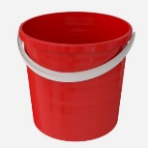   a. seashore guide b. phone (photos) c. bucket d. beachball
- In the event of lots of green seaweed (gutweed) on the seashore, which is extremely slippery I should… | Circle the correct answer:  - Skate across it  - Run across it and try not to fall  - Avoid it where possible and walk around it.
- Sometimes people leave bad stuff on the seashore or rubbish gets washed up from the sea. If I see lots of broken glass, jagged cans, syringes or large items of rubbish, oil or tar spills on the seashore, I will… | Circle the correct answer:  - Ignore it – it will wash away out to sea  - Let an adult know, so they can safely pick it up or arrange to inform your local council to organise a beach clean-up.  - Break it up into tiny particles, so it will degrade faster
- If there are small ‘safe’ pieces of rubbish on the seashore I can… | Circle the odd one out:  - Pick up at least three pieces of rubbish and bin it.  - Take the clean rubbish home and reuse it for seashore arts and crafts.  - Ignore it – someone else will pick it up.
- When going to the beach on a field trip for exploration, it is important to wear appropriate clothing for all types of weather. It is very important to have the correct footwear, for when walking over rocks. | Circle the type of foot wear I should NOT wear on a fieldtrip to the shore.  b  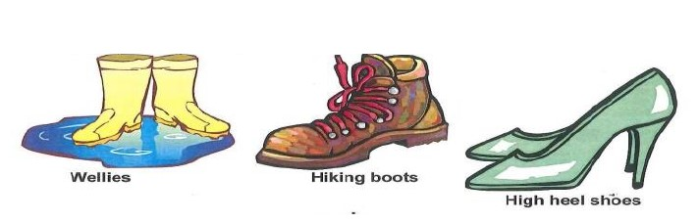 Flip-flops  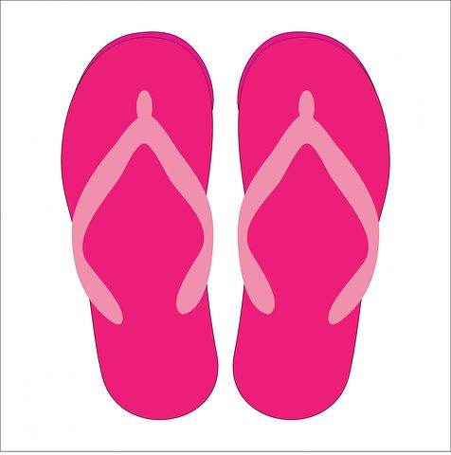  c  a
- When exploring the animals and habitats on the seashore I will make sure that I… | Circle the odd one out:  - Return live animals back to the place where I found them.  - Take as many live samples of seashore creatures home with me.  - Take photos and collect small seaweed and empty shell samples only.
- If I see birds nesting near the seashore what should I do? | Circle the correct answer:  - Explore the nest to see what I can find.  - Stay away – as the birds may get aggressive to protect their nest.  - Chase the birds down the beach.

Create a seashore safety & conservation code poster.
Seashore Safety and Conservation Code Poster

Your poster will need:
- A catchy Title & Message
- Seashore safety & conservation codes to inspire your friends and family to stay safe on the seashore as well as care for our seashore environment.
- Images, drawings or photos to inspire seashore safety and conservation in our local area.

We’ve included some pictures below that you can cut out and use on your poster. If you would like to share your poster with us, please send a photo of your artwork to us at www.explorers.ie

